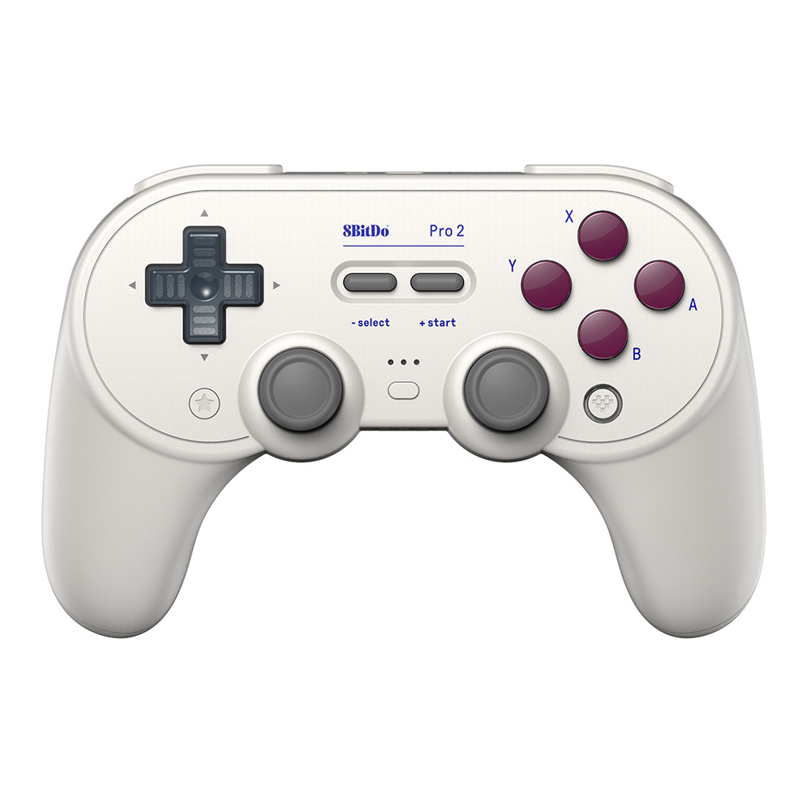

Vor

Zurück

Links

Rechts

Balancieren an

Balancieren aus

STEUERUNG BALANCIERENDER ROBOTER